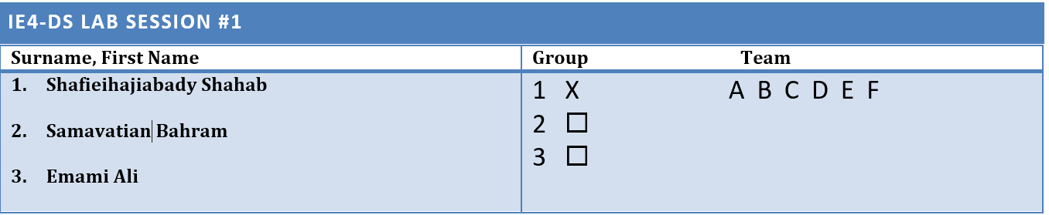

Lab 1 report

**Serial Interface Module to an ADC and DAC**

**Lab objective**:

In this lab task,we should develop a module for communication with a digital-to analog converter (Burr Brown DAC8801) that shall be connected via a 3-wire

serial data interface to the FPGA. Before the data can be sent to the DAC, the

data has to be serialized. In order to test the design, 12 bit data words are read

from switches connected to the FPGA and sent from there to the DAC via the

serial bus. In a second step, the DAC module is connected to an ADC module

(ADS7947) and the entire signal processing chain ADC-DAC can be tested.

**Task description**:

What we basically had to do was at first to design the DAC001 module

and then integrate it inside the ADC_DAC_TOP module and test the whole design virtually with ModelSim software and also practically with FPGA.The following are the steps we made to reach the final result.

1.**Design the DAC001 module**:What we realized was that the structures of ADC and DAC modules are partially similar to each other except that FSM and shift register blocks are different and also there is no save register block in DAC module.

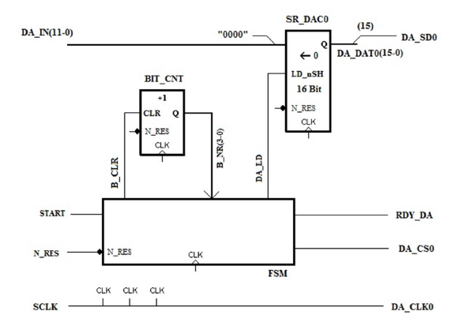

Figure 1: structure of the DAC module

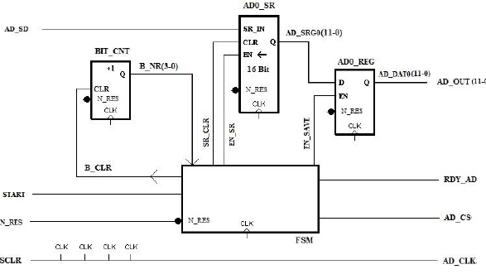

Figure 2: structure of the ADC module

.The FSM block has three Moore( DA_CS0, DA_LD,RDY_DA) and one Mealy( B_CLR) outputs.



Figure 3: FSM state diagram

Here is the VHDL code of the DAC001:

library IEEE;

use IEEE.std_logic_1164.ALL;

use IEEE.NUMERIC_STD.ALL;

entity DAC_001 is

port(SCLK, N_RES : in bit;

START : in bit; -- start signal

DA_IN : in bit_vector(11 downto 0) ;

RDY_DA : out bit;

DA_SD0 : out bit ;

DA_CS0 : out bit ;

DA_CLK0 : out bit );

end DAC_001 ;

architecture BEHAVIOUR of DAC_001 is

-- bit counter

signal B_NR : unsigned(3 downto 0):= "0000" ;

signal B_CLR : bit ;

--Control Signals DAC

signal DA_LD : bit; --if load '1' means start shifting else load in DA_IN

signal DA_DATA0 : bit_vector (15 downto 0) :=(others=> '0'); -- save all the shifted bits to DA_DAT0 and then from DA_DAT0 send always MSB to the DA_SD0

--states of the DAC communication module

type State_Type_DA is (IDLE_DA, LOAD_DA);

signal DA_STATE : State_Type_DA;

signal DA_NEXTSTATE : State_Type_DA;

begin

-- clock to DAC

DA_CLK0 <= not SCLK;

-- counter for serial bits -------------------------------

BIT_CNT: process(SCLK)

begin

if SCLK = '1' and SCLK' event then

if B_CLR = '1' then -- B_CLR is clearing the counter

B_NR <= "0000" after 5 ns ;

else

B_NR <= B_NR + 1 after 5 ns ; -- its output og bit counter

end if ;

end if ;

end process BIT_CNT;

SR_DAC0 :process (SCLK, N_RES)

begin

if N_RES ='0' then

DA_DATA0 <=(others=>'0') after 5 ns;

elsif SCLK = '1' and SCLK' event then

if DA_LD = '1' then

DA_DATA0 <= "0000"&DA_IN ;

elsif DA_LD = '0' then

DA_DATA0 <= DA_DATA0(14 downto 0) & '0' ;

end if;

end if;

end process SR_DAC0;

DA_SD0 <= DA_DATA0(15);

-- we have to create one(upper) FSM for whatever is related to clock and other FSM should contain all combinational logics

FSM_DA_REG : process(SCLK , N_RES)

begin

if N_RES ='0' then

DA_STATE <= IDLE_DA after 5 ns ;

elsif SCLK = '1' and SCLK ' event then

DA_STATE <= DA_NEXTSTATE after 5 ns ;

end if ;

end process ;

FSM_DA_SN : process(DA_STATE,B_NR,START) -- why don’t we combine both FSMs

begin

DA_NEXTSTATE <= DA_STATE after 5 ns ;-- idle state is our next state

DA_CS0 <= '1' after 5 ns ; -- CS is HIGH ( see Timing Diagram ) in IDLE STATE

DA_LD <= '0' after 5 ns ;

RDY_DA <= '0' after 5 ns ;

B_CLR <= '1' after 5 ns ;

case DA_STATE is

when IDLE_DA =>

RDY_DA <= '1' after 5 ns ;

DA_CS0 <= '1' after 5 ns ;

B_CLR <= '1' after 5 ns ;

DA_LD <='1' after 5 ns;

if START = '1' then

DA_NEXTSTATE <= LOAD_DA after 5 ns ;

end if ;

when LOAD_DA =>

DA_CS0 <= '0' after 5 ns;

B_CLR <='0' after 5 ns;-- we don’t clear until the shifting is in process

DA_LD <='0' after 5 ns;

if B_NR ="1111" then

B_CLR <='1' after 5 ns;

DA_NEXTSTATE<= IDLE_DA after 5 ns ;

end if ;

end case;

end process;

end BEHAVIOUR ;

2.**Simulate the DAC001 module**:

* ***Test bench:***

vlib work

vcom -93 -work work DAC_001.vhd

vsim DAC_001

# view signal wave forms

view wave

# number format is hex

radix hex

# show input signals

add wave -divider -height 32 Inputs

add wave -height 30 -radix default N_RES

add wave -height 30 -radix default SCLK

add wave -height 30 -radix default START

add wave -height 30 -radix default DA_IN

# show reg signals

add wave -divider -height 32 Reg

add wave -height 30 -radix default DA_DAT0

add wave -height 30 -radix default DA_LD

add wave -height 30 -radix default DA_STATE

add wave -height 30 -radix default DA_NEXTSTATE

# show DAC signals

add wave -divider -height 32 ADC_signals

add wave -height 30 -radix default DA_CS0

add wave -height 30 -radix default DA_CLK0

# show output of register

add wave -divider -height 32 Reg_output

add wave -height 30 -radix default DA_SD0

# generate input stimuli

force SCLK 0 0ns, 1 160ns -r 320ns

force N_RES 1 0ns, 0 33ns, 1 57ns

force START 0 0ns, 1 1000ns, 0 1320ns, 1 20000ns, 0 22500ns, 1 30000ns

force DA_IN AAA 0ns

run 50000ns

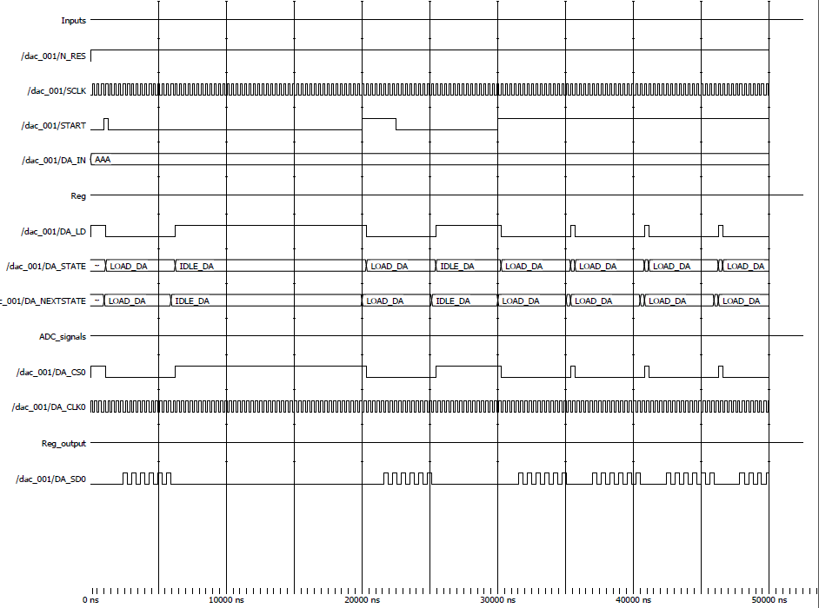

Figure 4: Simulation results

3.**Create an entity ADCDAC_TOP that instantiates the module DAC_001 S and adds the sample rate generator and the clock divider**.

Here is the VHDL code for ADCDAC_TOP module.

library IEEE;

use IEEE.std_logic_1164.ALL;

use IEEE.std_logic_unsigned.ALL;

entity ADCDAC_TOP is

port ( CLK, N_RES: in bit; -- 100MHz; asynch, active low reset

DA_IN : in bit_vector(11 downto 0) ;

-- M_ODE : in bit;

-- Signals to DAC0

DA_SD0 : out bit ;

DA_CLK0 : out bit ;

DA_CS0 : out bit );

end ADCDAC_TOP;

architecture BEHAVIOUR of ADCDAC_TOP is

component DAC_001 is

port ( SCLK, N_RES : in bit;

DA_IN : in bit_vector(11 downto 0);

START : in bit; --Startsignal

RDY_DA : out bit ; --Ready-Flag

---DAC0_SIGNALS

DA_SD0 : out bit ;

DA_CS0 : out bit ;

DA_CLK0 : out bit) ;

end component ;

component SR_GEN is

port ( CLK, N_RES : in bit; -- 100MHz; asynch, active low reset

START_TE : out bit);

end component SR_GEN;

component CLK_DIV is

port ( CLK, N_RES: in bit; -- 100 MHz; asynch, active low reset

SCLK : out bit); -- 3.125 MHz clk out

end component CLK_DIV;

signal START_TE : bit ;

--DAC-Signals

signal DA_INT_SD0 , DA_INT_CS0, DA_INT_CLK0 : bit ;

signal DIN_TE0 : bit_vector(11 downto 0) ;

--Takt, Taktteiler, Bitzaehler

signal SCLK : bit; -- interner Takt

begin

DIN_TE0 <= DA_IN ;

DA_SD0 <= DA_INT_SD0 ;

DA_CS0 <= DA_INT_CS0 ;

DA_CLK0 <= DA_INT_CLK0 ;

DAC_0 : DAC_001

port map ( SCLK, N_RES , DIN_TE0 , START_TE, open, DA_INT_SD0, DA_INT_CS0, DA_INT_CLK0 ) ;

SR_GEN0 : SR_GEN

port map ( CLK, N_RES, START_TE);

CLK_DIV0: CLK_DIV

port map (CLK, N_RES,SCLK);

end BEHAVIOUR ;

4.**Simulate the ADCDAC_TOP module**.

* ***Test bench:***

vlib work

vcom -93 -work work ADCDAC_TOP.vhd

vsim ADCDAC_TOP

view wave

radix hex

add wave -height 30 -radix default sim:/ADCDAC_TOP/*

force CLK 0 0ns, 1 160ns -r 320ns

force N_RES 1 0ns, 0 33ns, 1 57ns

#force START_TE 0 0ns, 1 1000ns, 0 1320ns, 1 20000ns, 0 22500ns, 1 30000ns

force DA_IN AAA 0ns 10ns, DDD 25000ns

run 60000ns

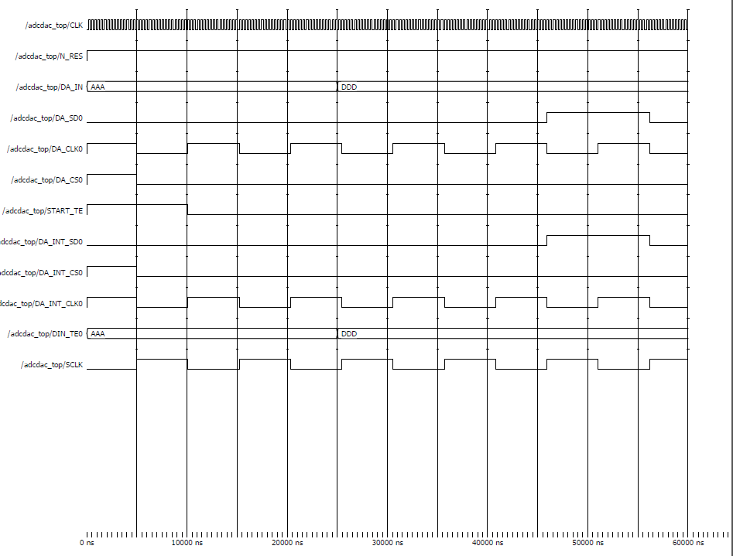

Figure 5: Simulation results

5.**Implement the top level module ADCDAC_TOP including DAC module on the ML507 Board**:

After simulating DAC and ADCDCA_TOP modules with ModelSim software and getting the desired results we started implementing the ADCDCA_TOP module on the FPGA and tested the DAC with with 12 switches of the SLB board and applied different digital values to our DAC module and compared the value to the analog output voltage of the DAC.We set M_ODE to 0 by turning off the 7th switch of the SLB board to get the data from it.We obsereved that the output voltage range was not between -1 and +1, and was lower instead, and that was because of using an amplifier extra added to the circuit.So with the help of the lecturer we changed the code(shifted the data being saved in the shift register by two the left) so that the output was in the range of -1 and +1. Below are the results of different test cases using oscilloscope.

**Hint** : The signals in the screenshots are CS0,CLK0 and D0 of DAC8801 from up to down.

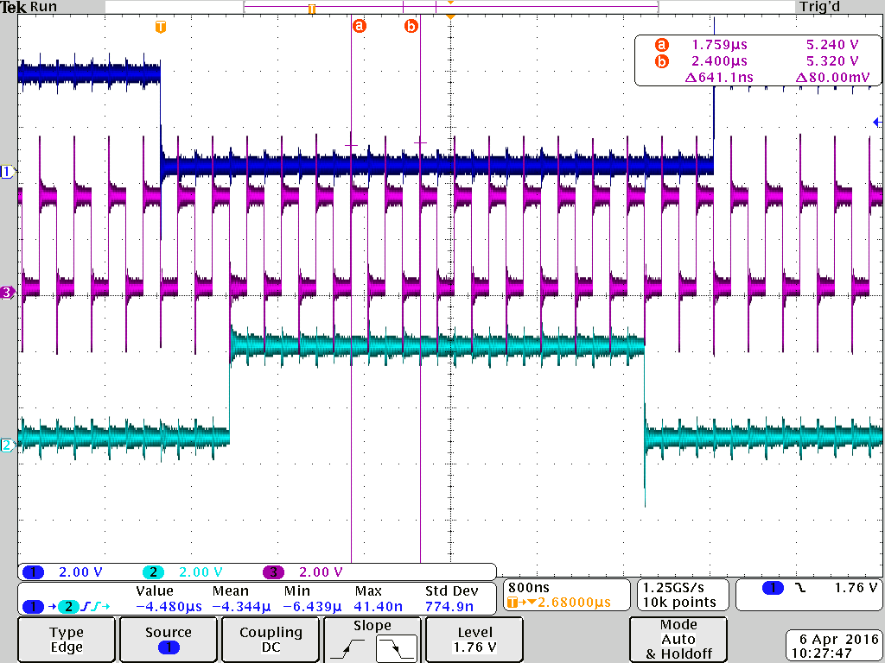

Figure 6: set all the switches on

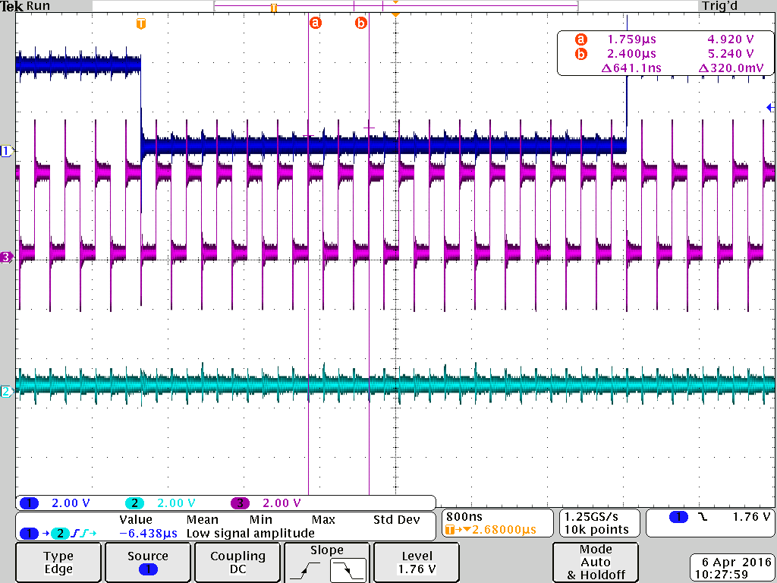

Figure 7: set all the switches off

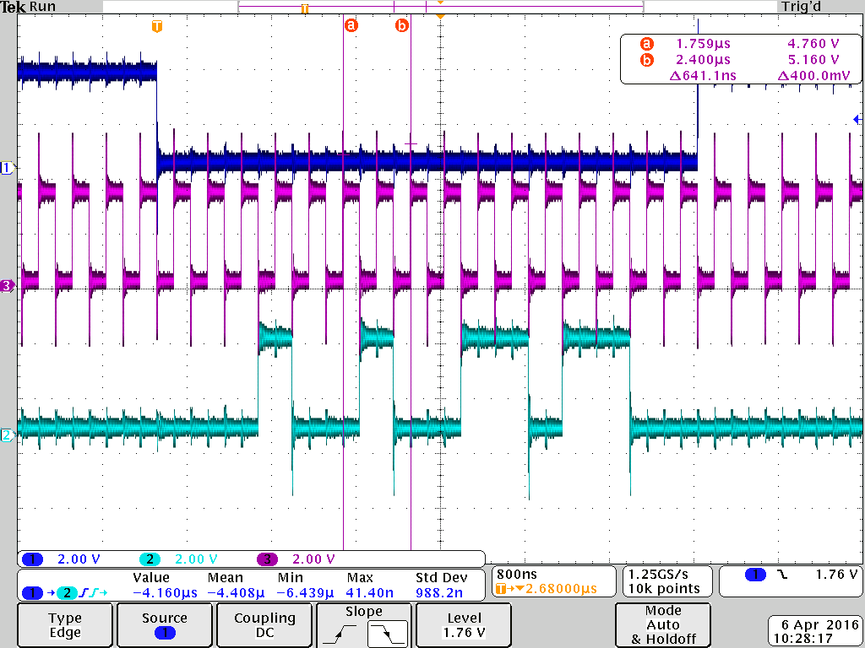

Figure 8: set 0100 1001 1011 as a random pattern

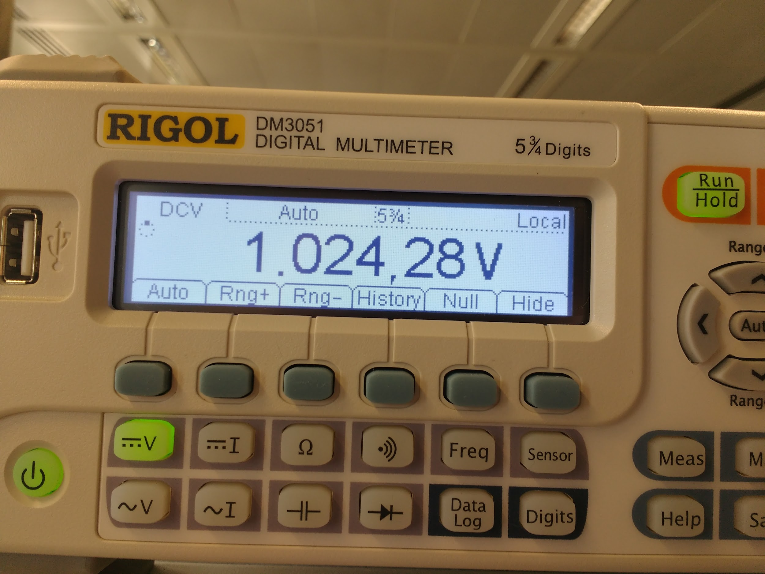

Figure 9: testing the max value of DAC output0

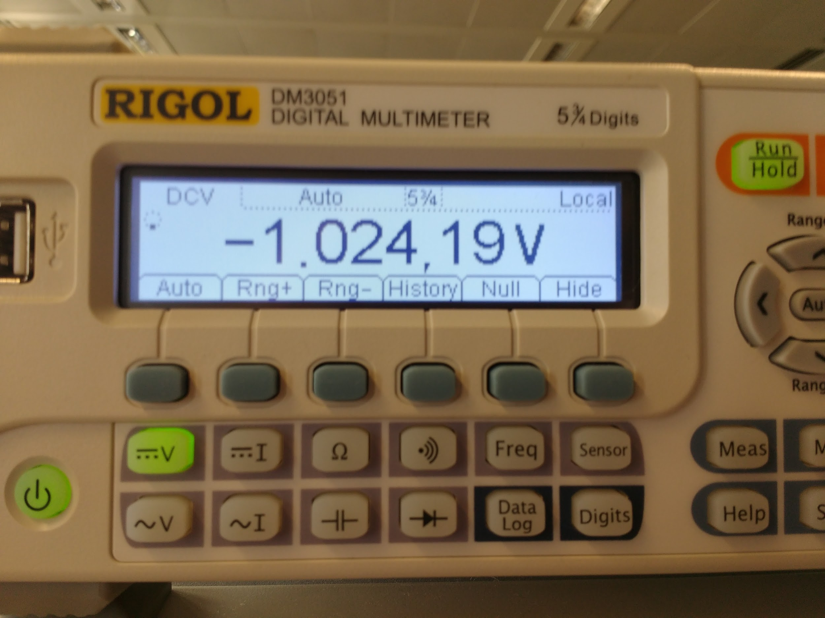

Figure 10: testing the min value of DAC output0

6. **Implement the top-level module ADCDAC_TOP including DAC and ADC**:

Next we applied a voltage in the range -1V to +1V to the ADC and

measure the serial data signals from ADC and to DAC and compared the results.

Afterwards we applied a sinusoidal signal with amplitude of 1V to

the ADC and determined the amplitude and delay of the DAC output.Below are the screenshots of the results shown by the oscilloscope.

**Hint**: The purple signal in the following screenshots is the input and the blue one is the output of module ADCDAC_TOP.

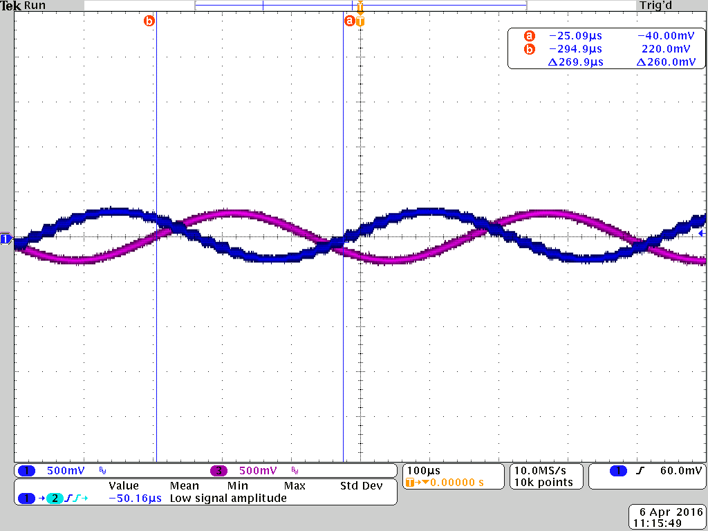

Figure 11: Check with 2.2 kHz frequency we had delay of 269.9µs.

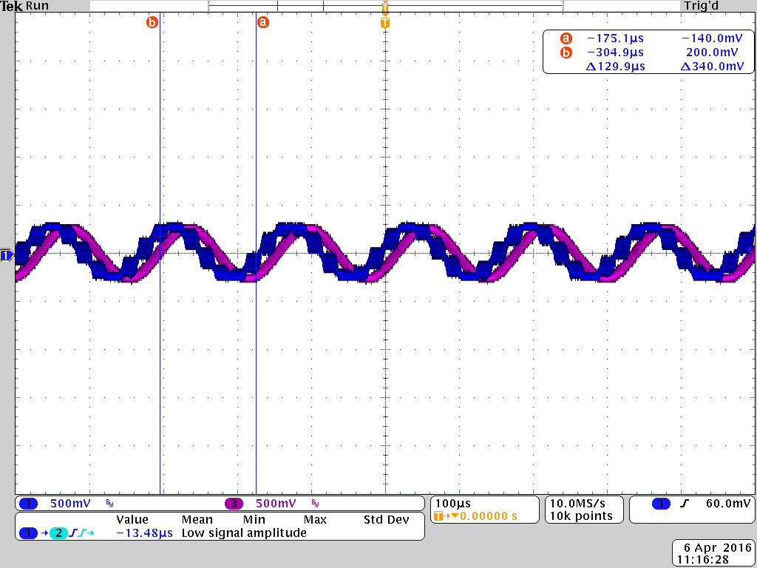

Figure 12: Check with 6.2 kHz frequency we had delay of 129.9µs.

**Conclusion**: We observed that the input and output signals were similar to each other but there was delay between them. When we increased the frequency of the input signal,the propagation delay decreased,however the output accuracy became lower.